Abstract—A paper based on the design of a chemistry based puzzle game. The design of the game is meant to teach the basic concept of chemistry related to covalent bonds. The area of Educational Technology is still not developed for young learners. Interactive technology is required for learning effectively and efficiently. While teaching the basic concept of Chemistry, like bonds between atoms and how molecules are formed, teachers usually give examples to define the formation of bonds. However the concept of atoms and molecules are difficult for students to imagine. This game A2M clearly presents the concept lying behind the formation of bonds. The game rules and simple game levels are used as a teaching aid along with a fun puzzle game. The purpose of this game is to combine fun with education.
Interactive Entertainment Software for Learning Chemistry
Maya Agarwal¹, Bengal Institute of Technology, WBUT, India
Shubhajit Saha², Bengal Engineering and Science University, Shibpur, India
¹maya.agarwal2@gmail.com, ²shubhajit.saha@students.becs.ac.in
Index Terms— Chemistry, Game Based Learning, Game Design, Puzzle.

INTRODUCTION
TECHNOLOGY can be used for teaching in the classroom. In the last decade, technology has brought revolution in the methodologies of teaching, from the use of calculator, computer, Distance learning, E-learning etc [1, 2]. Digital gaming technologies help us explain concepts in a new way that would otherwise not be possible, efficient, or effective, with other instructional methods [3]. Game based learning amplifies the potential of computer games and design techniques. Many digital games were designed in the last decade to teach computer Science [4], History [5], Boolean Logic [6]. Although Digital learning games are simplified caricature of e-learning, it is a more engaging experience that can bring behavioral changes. Games encourage application of knowledge, creativity and problem solving skills that cannot be gained by reading texts [7]. In my current project, I have designed a game to teach the critical concept of Chemistry to young learners. This paper is organized as follows. First I have discussed the Game Description. Secondly, the details of the different objects used in the game. Then, I have described how to use the game for teaching purposes. Finally, I have reported my findings from a user study with a group of students.

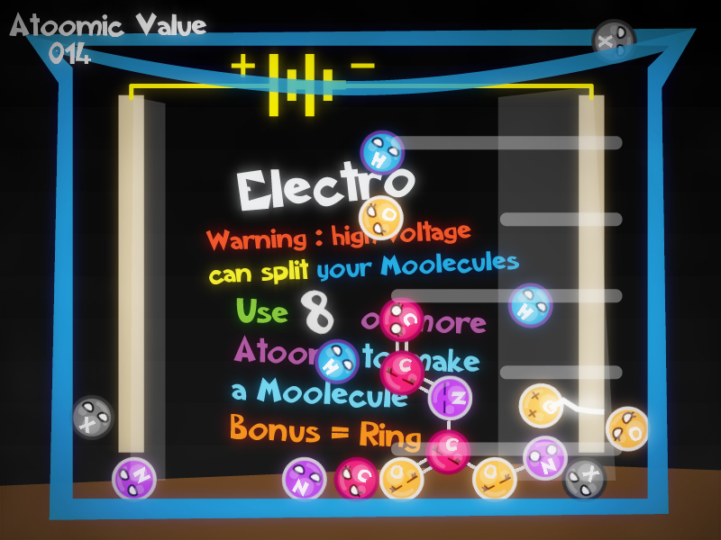

Fig. 1. Atoms to Molecule game.

Game Description
A single player puzzle game, where the player is in a Chemistry lab. Each level consists of lab equipment and atoms. The player can drag and drop atoms to make bonds with the nearest atom [8]. The task is to make molecules and solve different puzzles of the Chemistry lab. Molecules can be formed by joining different atoms.
The player can arrange atoms to make big, small, linear and ring molecules. To make a complete molecule, all the atoms in the molecule must be stable which can be achieved by using all their bonds. The eyes on the atoms indicate the different states an atom can have (see Table 1). The lab equipment in which A2M can be played are test-tubes, beakers and conical flasks (see Fig. 1). Table I: Eye Characterization state chart

Basic Game Components
State | Eye Characterization |  | Indication
State | Female | Male | Indication
Normal |  |  | The atom is free from bonds.
Unstable | 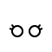 |  | Some of the atoms bonds are satisfied.
Stable |  |  | All the bonds of the atoms are satisfied.

Atoms
The main character of the game is the atom. The art work of the atom is done keeping in mind young learners. The symbol in the head and the circular body’s color indicates the type of element. The four elements with varying number of bonds used in this game are Hydrogen, Oxygen, Nitrogen and Carbon (see Fig. 3).

Fig. 2. Details of Carbon Atom
Symbol

Eye

Bond

Fig. 3. Different kind of bonds.
Free bonds

Possible
bonds

Old bonds
When an atom is dragged and dropped near another atom, a bond is formed between them. Bonds can be Single, Double or Triple. The atom always tries to make the highest number of bonds. When an atom is dragged the free bonds are highlighted. When it is brought near another atom it also shows the possible number of bonds that can be formed (see Fig. 3).

Visual Structure of the Molecule
A gameplay experience feature that makes the game engaging by giving good visual feedback about the state of the molecule. The newly attached atoms arrange themselves in an aesthetically appealing formation with suitable angles between the bonds.

How to Use the Game for Teaching purposes
The game is developed focusing on two aspects, teaching and game play. Both the components are balanced in an equal ratio to make the game engaging and entertaining. The goal of the game is to “Make the bonds and break the bonds”. It helps the player to clearly understand the concept of covalent bonding.
A2M is a puzzle based game on the covalent nature of atoms. The atoms are used as puzzle pieces. To form a molecule the player has to solve engaging puzzles. While solving these puzzles, the player learns how molecules are formed, using single, double or triple covalent bonds, between atoms.
Male and female genders have been assigned to the atoms to distinguish between atoms that have odd number and even number of bonds to enhance the user experience. The feature makes the game both fun and educational. The use of eyes for the characterization of the atoms is effective in making the player understand the stable and unstable nature of the atom. Rather than reading it from textbook, with real experimentation, players get to absorb the concept in a fun way. The biggest asset of the game is the right balance between entertainment and education. It keeps students engaged with the game for a long time.

Implementation
A2M was developed using Microsoft XNA [9], a cross-platform game framework, using C# object-oriented language. With the help of XNA game studio it was easier to implement the entire game as it makes easier graphical and game loop implementation.

`User Study
To evaluate the learning achievement through the game, a group of 50 students was selected randomly from seventh and eighth Grade to understand the gameplay experience and improve the game design. The research questions were designed to gather the feedback aimed at improvement of the game and understand how the design was helpful in teaching the players about molecule formations and to determine how the characterization of the atoms helped to grab the attention of the young learners. The main goal was to realize how educational games can hold the interest of the player and how much knowledge they gain after playing the game. Efforts were made to understand the learning patterns among children through games. Observation notes were taken during game play, to record interesting movements of players and to generate related questions for their interview. The observation included how the player interacts with the game and the reaction of the player on their first interaction with the game. At the end of the user study, a semi-structured interview was conducted which focused on understanding the subjective experience of the players, including the strategies they adopted, things they learned, what made them adhere to the game.
Positive feedback about A2M was obtained from the study (see Table. 2). As a part of the survey, students were asked to rate the game on a scale of 1 to 5. The parameters chosen were Learning, Fun, and Re-play value.
TABLE II:
Feedback Score
Rating | Learning | Fun | Re-play value
0 – 1.5 | 5 | 7 | 13
1.5 – 3.5 | 13 | 27 | 27
3.5 – 5.0 | 78 | 65 | 60
The rating values of all the parameters are calculated as the percentage of total students.

Conclusion And Future Work
Educational gaming is a vast field of research due to its high potential. The main purpose is to bring about a new method of learning covalent bonding with a practical approach. It helps students to grasp complex concepts in an entertaining method. In the meantime, more efforts will be made to explore more interesting concepts of Chemistry which can be included in the game. Ideas to implement the game in mobile Java platforms will also be explored as mobile phones are low-power devices and can reach out to billions of people [10].
References
- Groff, J., & Haas, J. (2008). Groff, J., & Haas, J. (2008). Web 2.0: Today’s technology, tomorrow’s learning. Learning & Leading with Technology, September/October 2008.
- Groff, J., & Mouza, C. (2008). A framework for addressing challenges to classroom technology use. Association for the Advancement of Computing in Education (AACE) Journal, 16(1), 21-46.
- Prensky, M. (2001). Digital game-based learning. New York: McGraw Hill.
- Teaching Computer Science through Game Design Mark Overmars, Utrecht University.
- Nor Azan Mat Zin 1, Wong Seng Yue 2 History Educational Games Design Faculty of Information Science and Technology, National
- Teaching Boolean Logic through Game Rule Tuning Jui-Feng Weng, Shian-Shyong Tseng, Member, IEEE, and Tsung-Ju Lee
- Annetta, L.A. and Cheng, Meng-Tzu. Why educational video games?In. Annetta, L.A. Serious educational games: from theory to practice,Sense Publishers, Rotterdam, 2008.
- 2D Boy, World of Goo, http://www.worldofgoo.com/, 13 October, 2008.
- Microsoft, App Hub, http://create.msdn.com/, March 4, 2004.
- CNN. Weapon against epidemics: cellphones. Hhttp://edition.cnn.com/2009/TECH/science/06/16/cellphones.health.disease/H (Last accessed September 17, 2009).

